BLOG instructions Pages for children to post work on:
- Go to the main Academy BLOG page: hexthorpeprimarycademy.net
- You may want to save this web address on your favourites on a PC or on the favourites on an IPad.
- You can on the Ipad go through the Astrea App if you find that easier. This is the page you need to see:
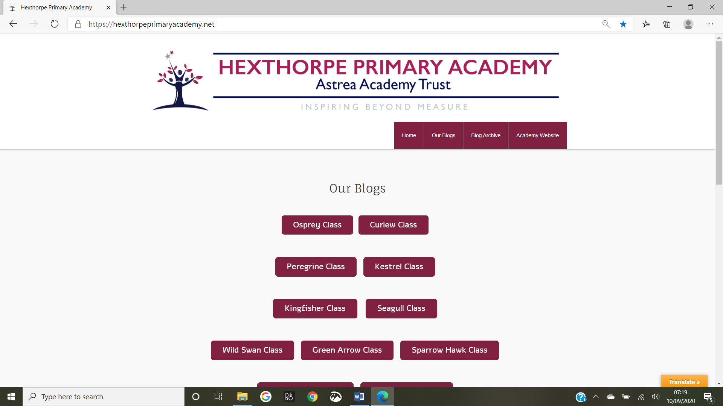

- You have a range of different forms for you to post your work in. These are the formats for writing something on your class BLOG:
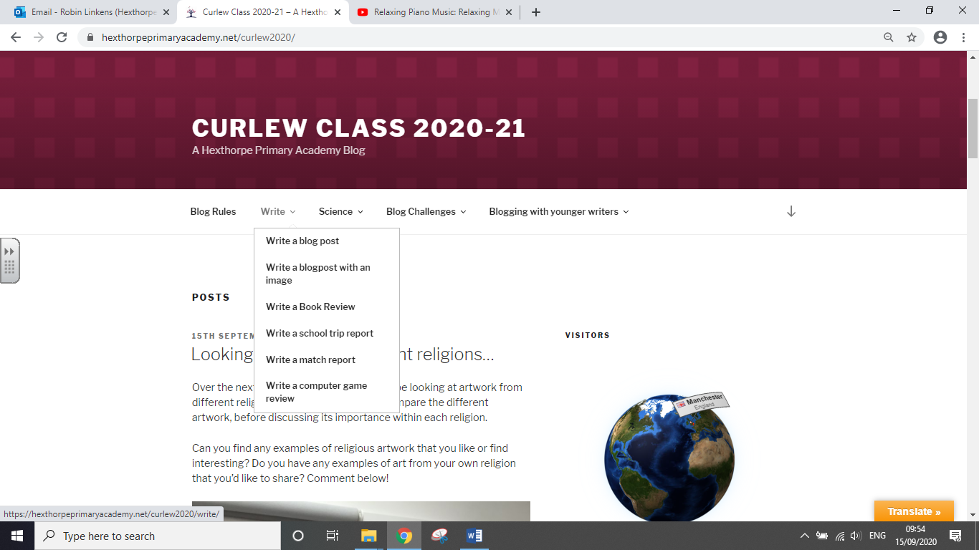
The next few pages shows you examples of what is available on the drop-down menus.

This is what the basic writing format looks like:
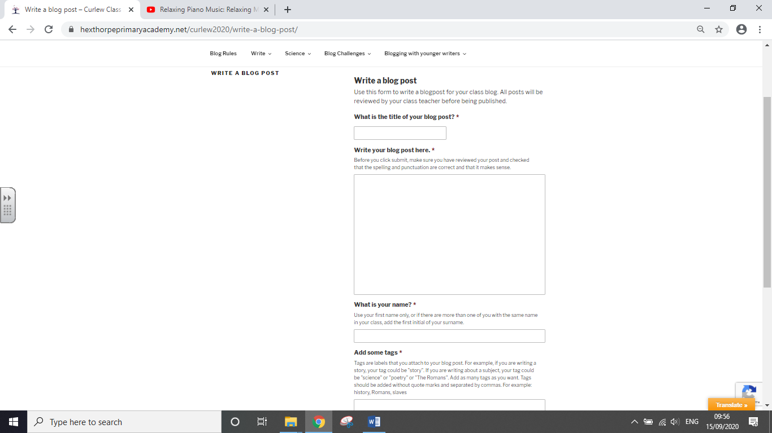

This one is for writing, but you can add a photo as evidence of your work:
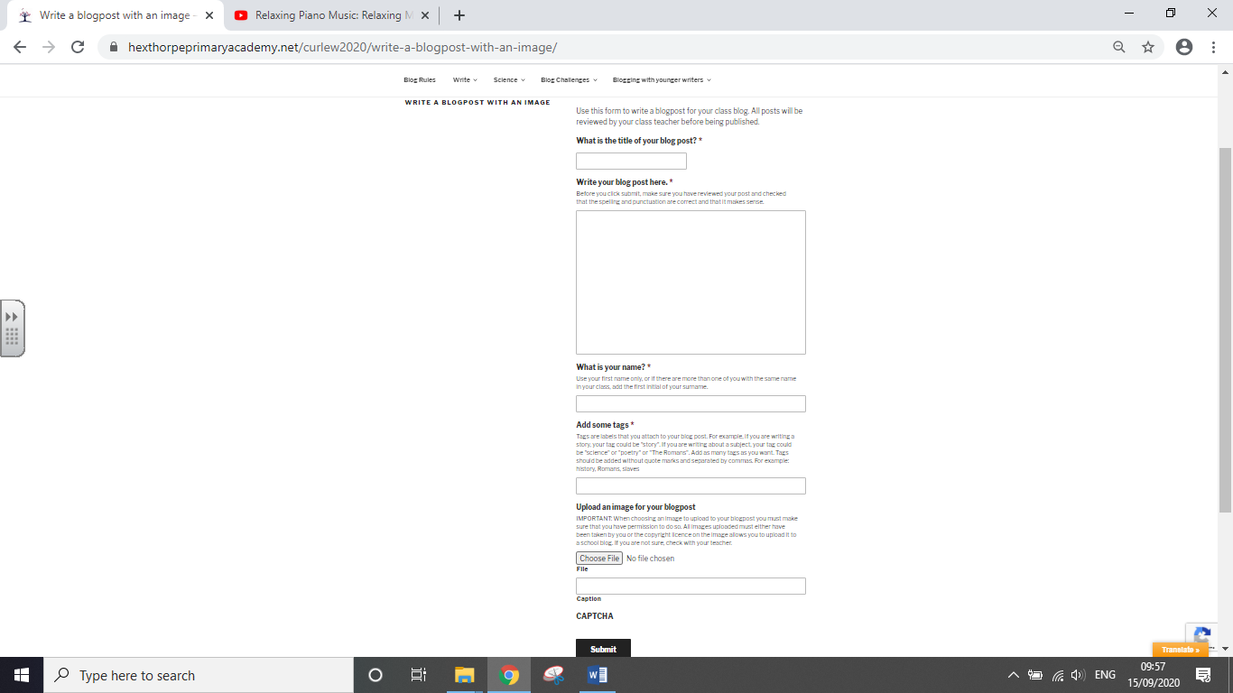
To add a photo of your work, you upload the photo file using this section.

This one in the writing section is for a book review:
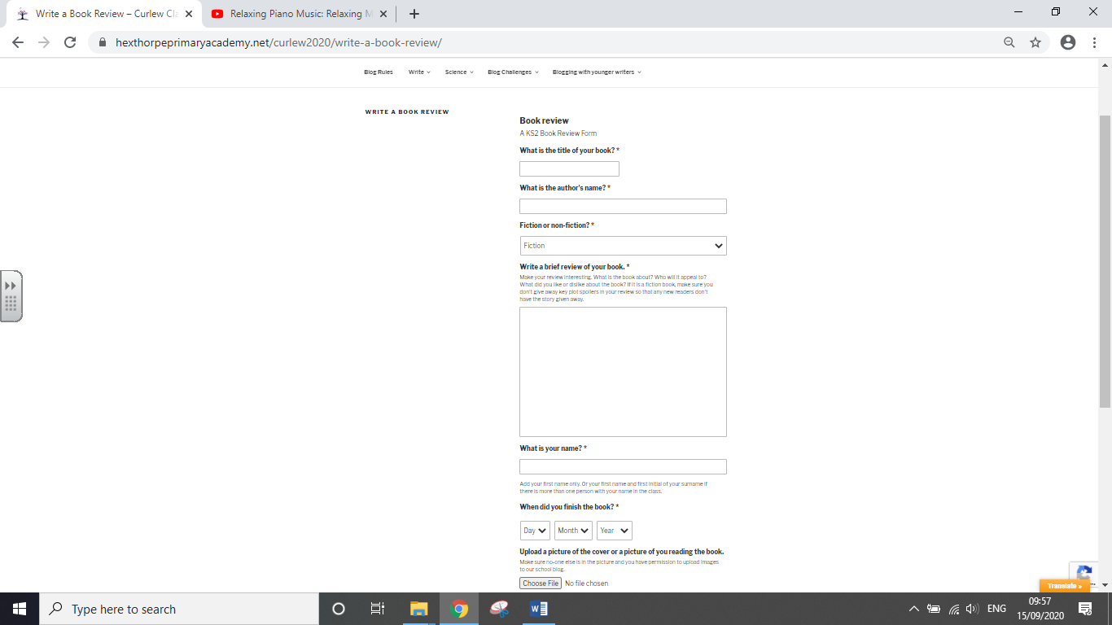

This one is for a sports activity/match write up for sports fanatics! :
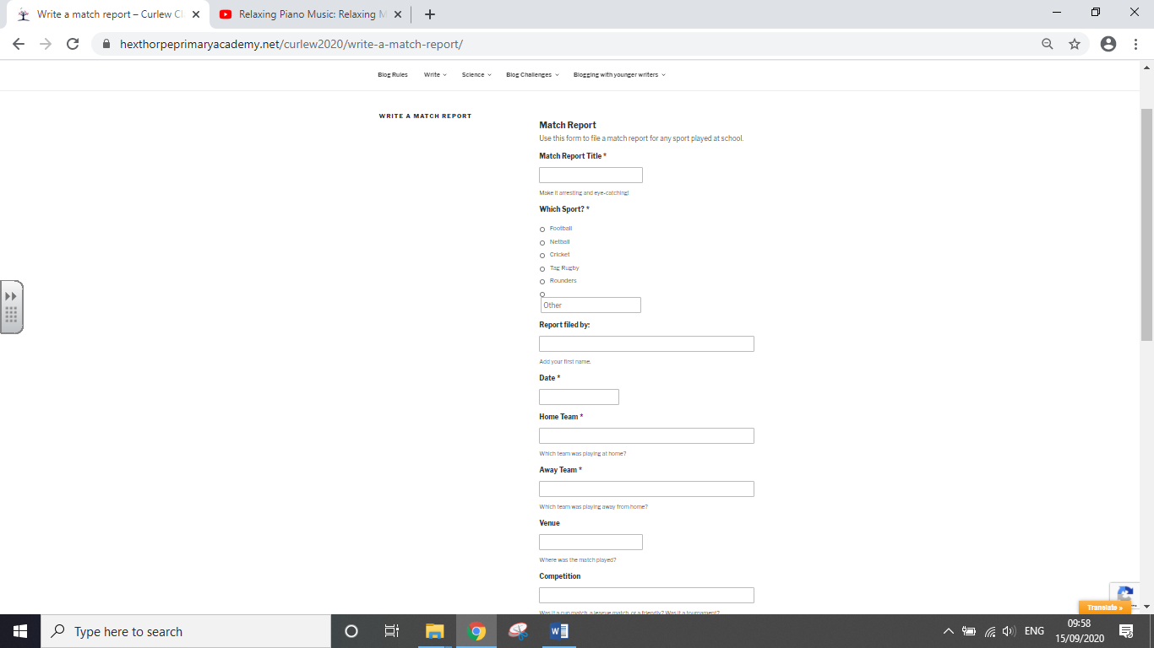

There is also one for the computer game explorers:

- Next you have a drop-down section for challenges:
There are 4 forms for you in this section:
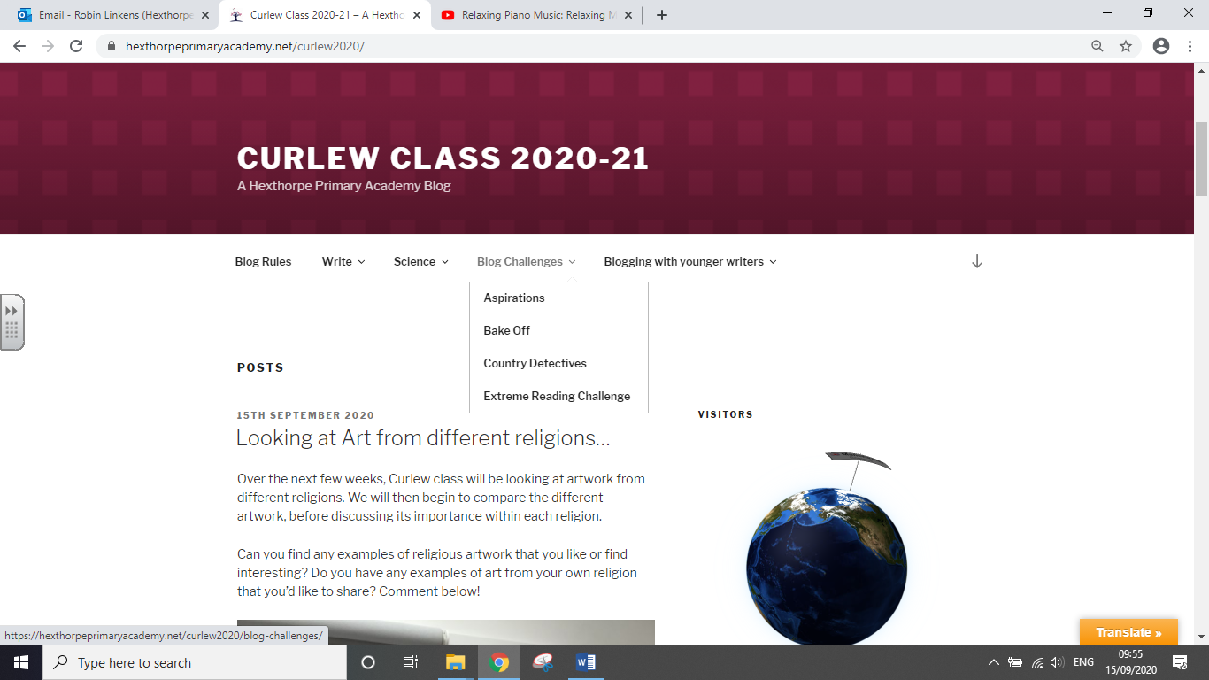

Careers/ Food technology/ Geography/ Reading

