For PC/laptop and Mac users..
1. Open your browser; such as Google chrome, Microsoft Edge or Safari.
2. Go to www.office.com (Arrow 1)
3. Click ‘Sign In’ (Arrow 2)
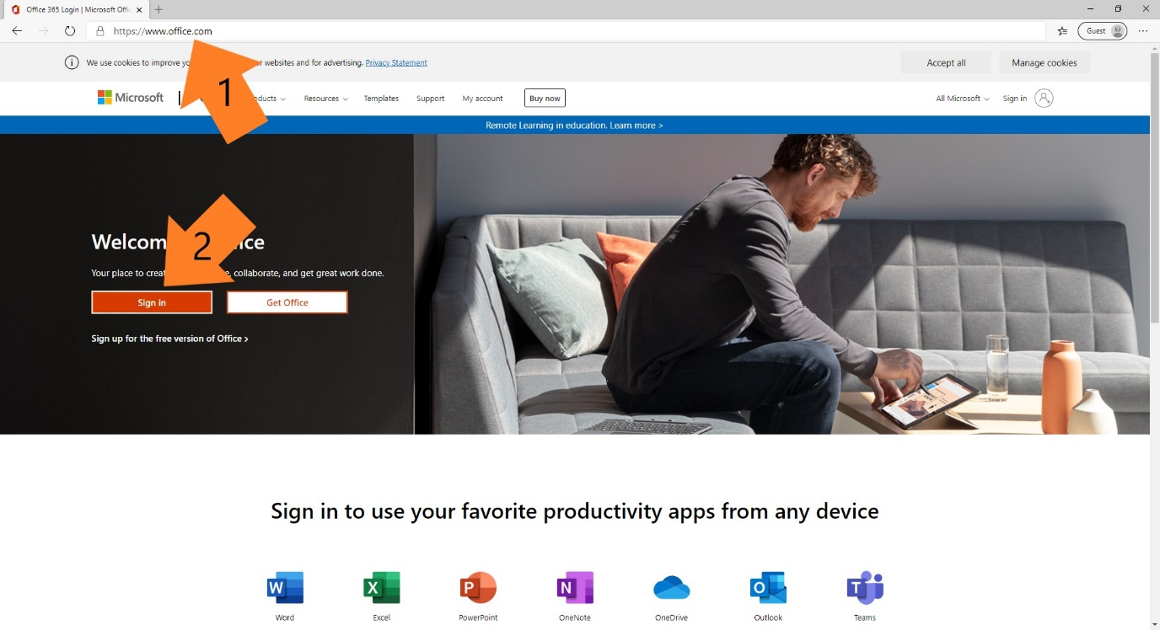
4. Enter the details provided by school e.g. your.name@astreahexthorpe.org
5. Enter the password (the password IS case sensitive)
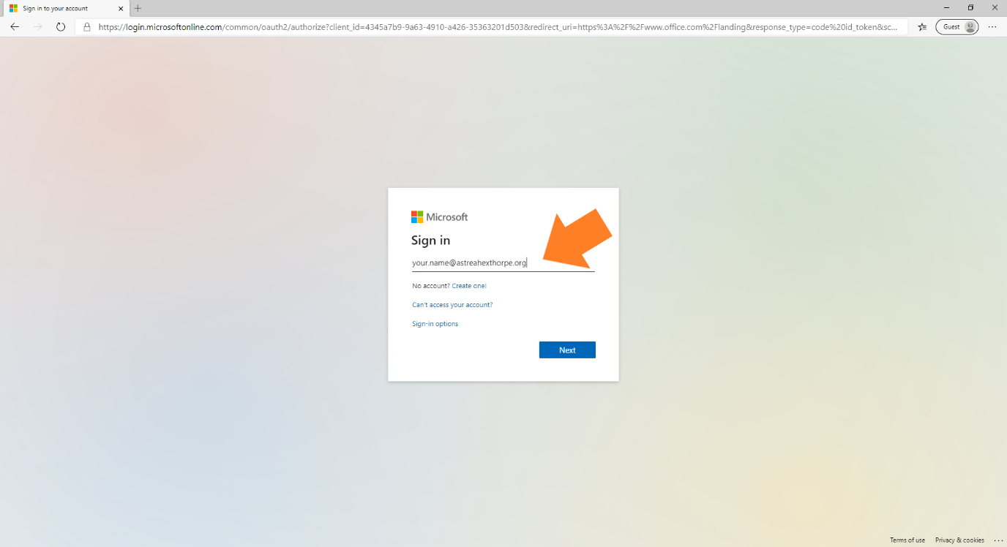

6. Click the Microsoft Teams logo as shown.
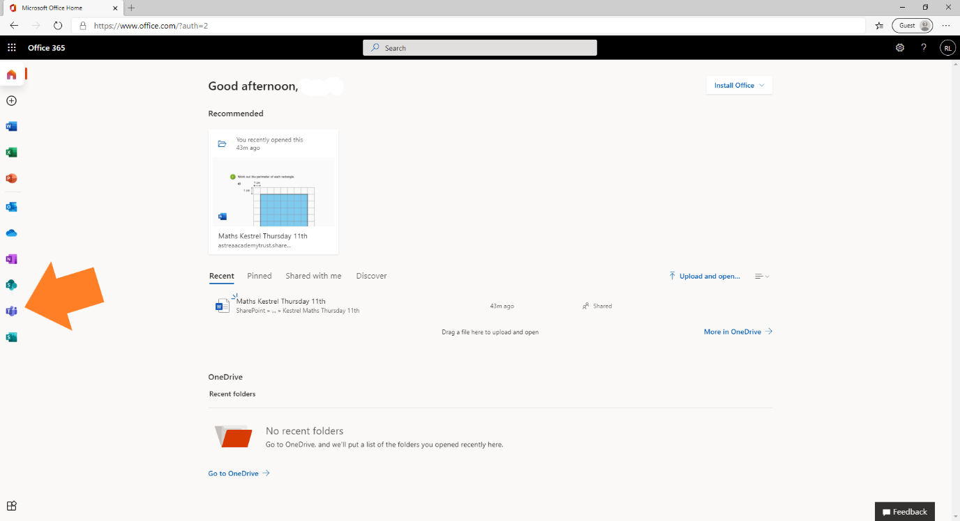
7. You will be prompted to either download the app or continue in your browser.
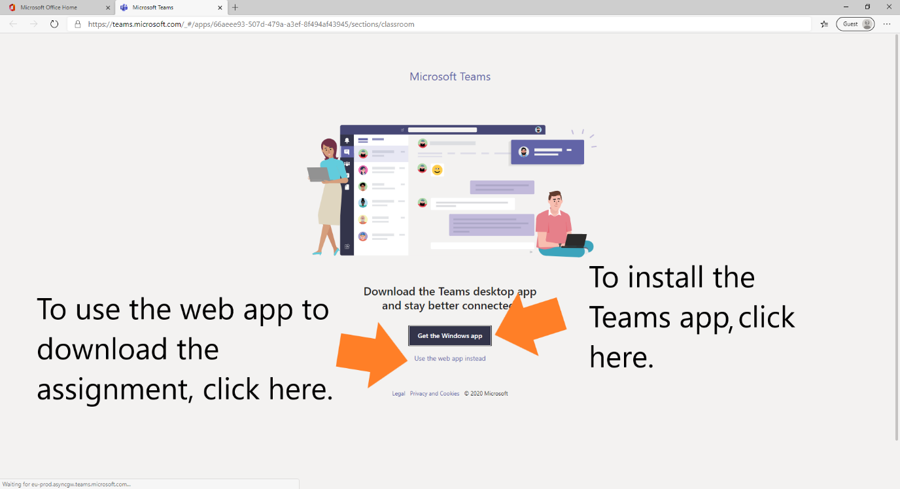

8. Click ‘Assignments’ (Arrow 1).
9. Click the assignment (Arrow 2)
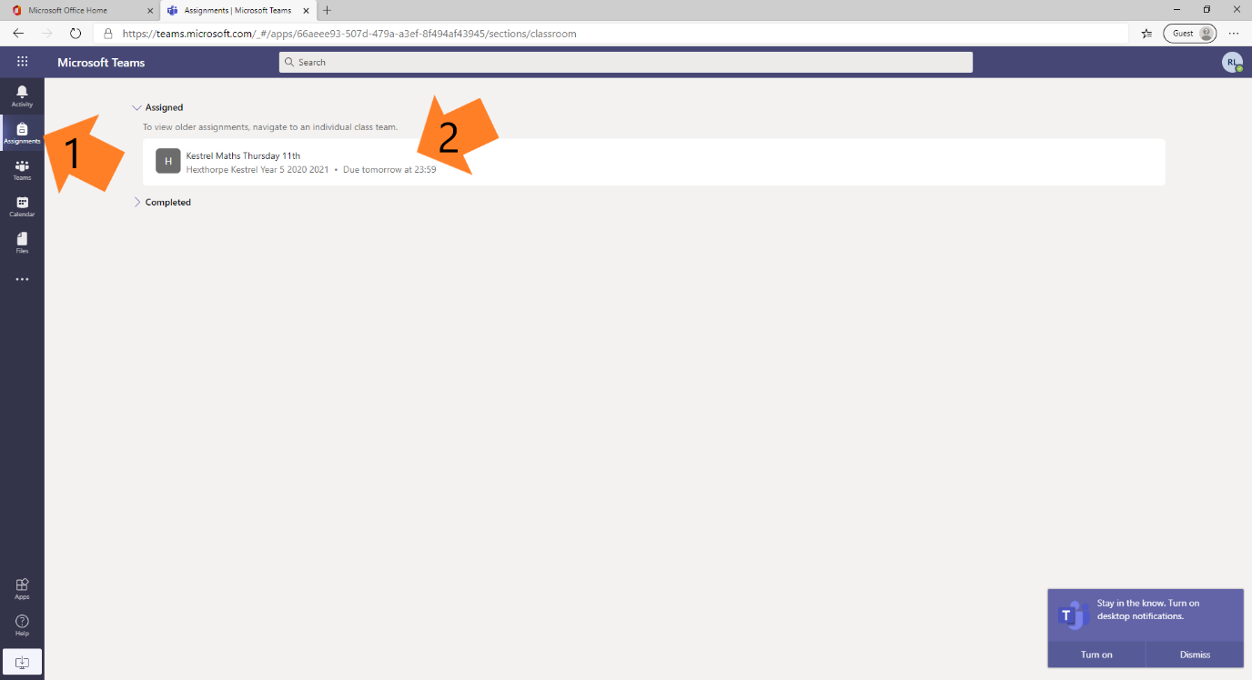
10. Click the document to open it (Arrow 1).
11. When you have completed the assignment click ‘Hand in’
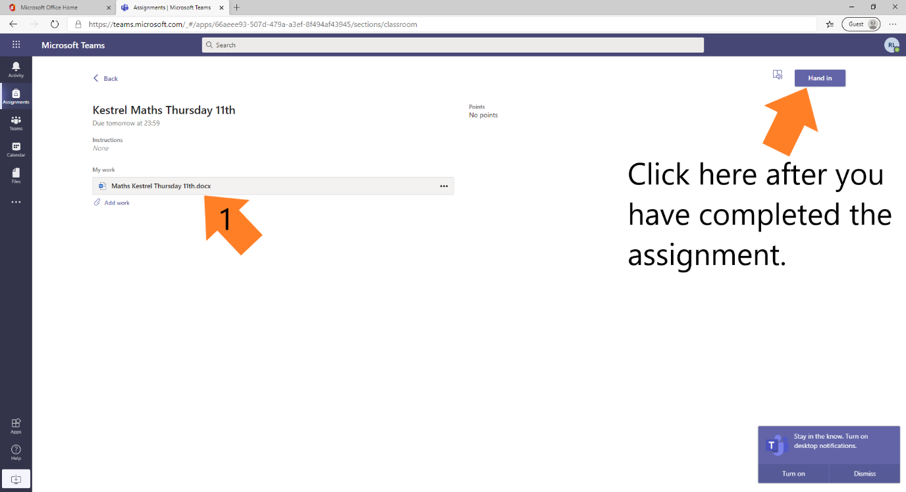

If you are using the Microsoft Teams app the instructions.
1. Open the app and log in using the details provided by school.
2. Click ‘Assignments’ (Arrow 1).
3. Click the assignment (Arrow 2)
4. Click on your name and complete. You will be able to see the status of the assignment and any feedback the teacher has given here. (This screen cannot be shown for safeguarding reasons)
For a mobile device or tablet such as iPad or Samsung..
1. Install the Microsoft Teams app using the app store.
2. Sign in using the details provided by school similarly to the PC/Mac instructions further up.
3. Click Assignments (Arrow 1).
4. Click the assignment (Arrow 2).

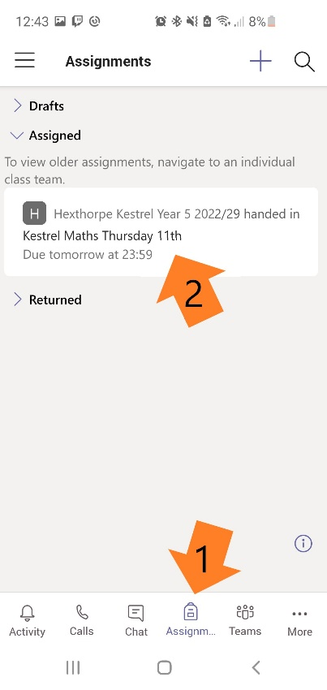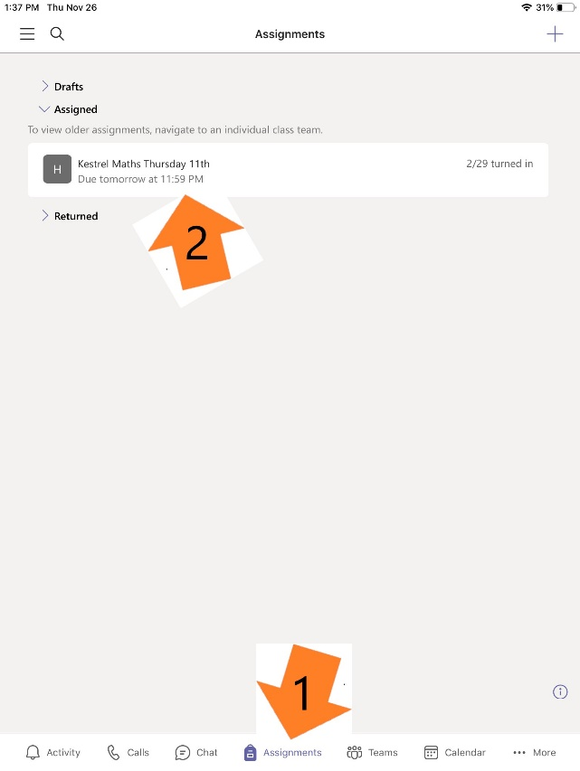

Once the assignment is open..
1. Read the questions then type your answer next to the red text below it (Arrow 1). Do this for all questions.
2. Once the assignment is complete, click the ‘Close’ button (Arrow 2). This will automatically save your work.
3. You can change any of your answers before the due date.
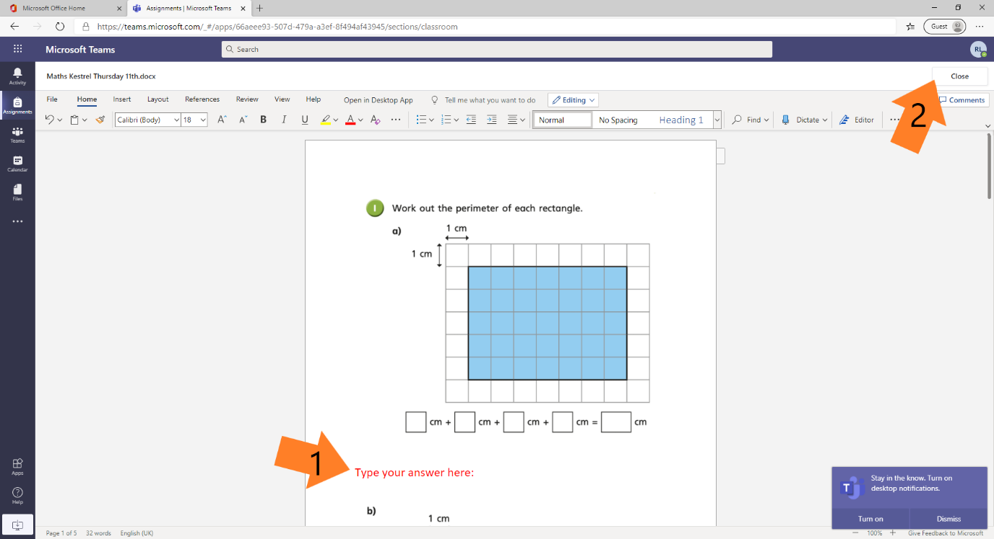
If you require any further assistance please contact school…
Telephone: 01302 852245
Email: admin@astreahexthorpe.org

